R. Reports Menu: G. Discharge Report

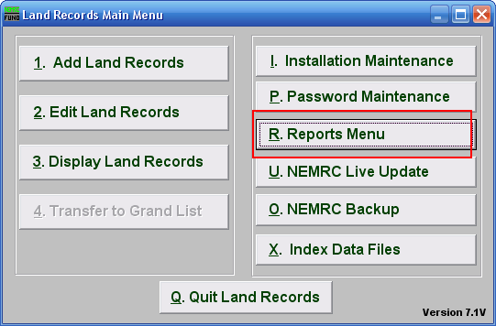
Click on “R. Reports Menu” from the Main Menu and the following window will appear:

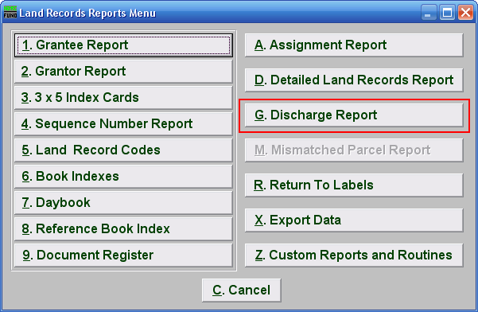
Click on “G. Discharge Report” from the Reports Menu and the following window will appear:
Discharge Report

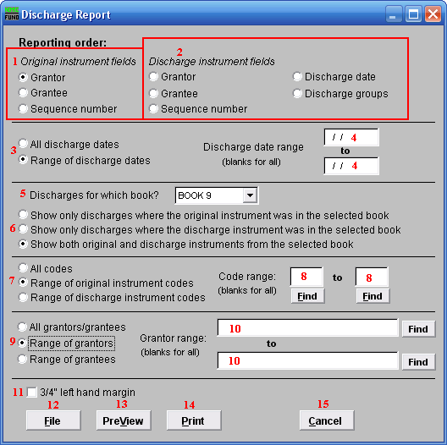

- Original instrument fields: Select the primary sort order from the originating documents.

- Discharge instrument fields: Select the secondary sort order from the discharge document.

- All discharge dates or Range of discharge dates: Select if you want to report on all discharges or on a specific discharge date range.

- Discharge date range: Enter a beginning and ending date range to report.

- Discharges for which book?: Select an item from the drop down list for reporting.

- Show only…: Select the appropriate group of activity you want to report on from the items presented.

- All codes OR Range of original/discharge instrument codes: Select the choice of reporting on all codes or a specific range of codes.

- Code range: Enter a specific range of codes to report or leave these fields empty to report on all codes. You may pick your start and ending ranges from a list by using the find button

- All grantors/grantees OR Range of grantors OR Range of grantees: Select the option to further restrict the report to a range of your primary sort grantor or grantee, if desired.

- Grantor range: Enter the starting and ending grantor/grantee (as selected) or pick from a table by clicking on the “Find” button.

- ¾” left hand margin: Check this box to have the system create a three quarter inch left margin for binding of the report.

- File: Click this button to save this report on this computer. Refer to GENERAL FILE for more information.

- PreView: Click this button to preview this report. Refer to GENERAL PREVIEW for more information.

- Print: Click this button to print this report. Refer to GENERAL PRINTING for more information.

- Cancel: Click “Cancel” to cancel and return to the Report Menu.

